Electronics Documentation

1. Electronics Block Diagram

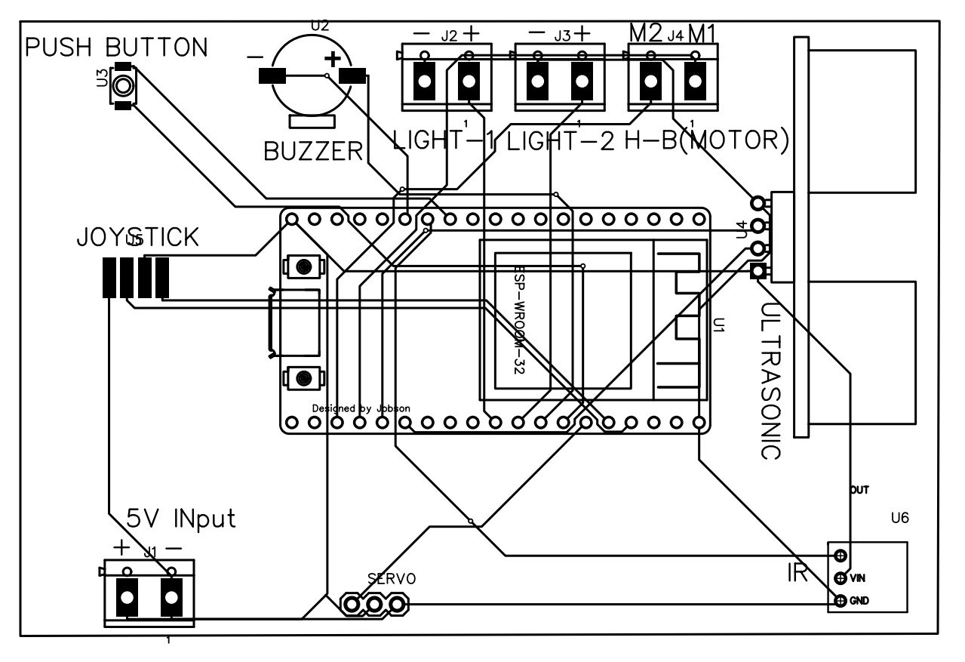
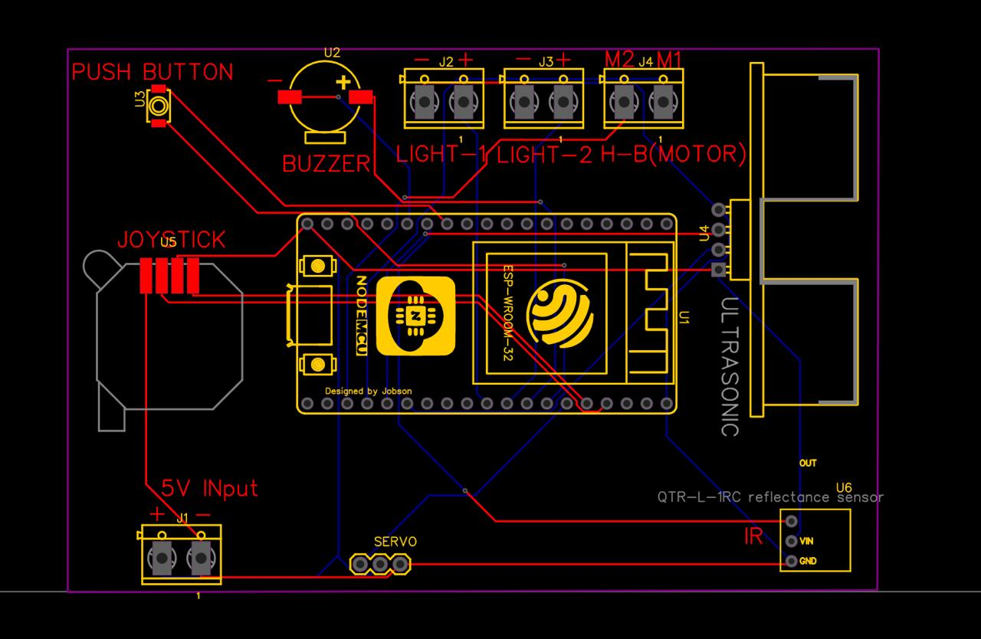

2. Components Table
Component | Quantity | Purpose | Justification
DC Motor | 3 | To move the claw along all 3 axis (left-right, front-back and up-down) | DC geared motors provide high torque at low speeds, which is essential for lifting the claw and moving loads smoothly
Servo Motor | 1 | To open and close the claw | Servo motors allow precise angle control, which is required to accurately grip and release objects
Joystick | 1 | To enable the user to navigate the claw to the desired location | A joystick provides intuitive 2-axis control, making it easy for users to control movement
Neopixel strip | 2 | To enhance user experience and indicate game status (win/lose) | NeoPixels are individually addressable allowing programmable animations and color patterns for visual feedback during the game
IR Obstacle Detection Sensor | 1 | To detect the coin and start the game | IR sensors provide fast output at short ranges without any physical contact
Ultrasonic sensor | 1 | To detect if an object is successfully dropped or not. | Ultrasonic sensors enable accurate detection of whether an object has reached the collection bin. (Unlike IR sensors, its performance is not affected by object color or surface reflectivity. This makes it more accurate for detecting objects of varying shapes and materials in an open space.)
Push Button | 1 | To allow user drop the claw and attempt to collect the object | Provides a simple and reliable input mechanism for triggering the claw action
Buzzer | 1 | To provide audio feedback for the game events | Sound feedback enhances user interaction and makes the game more engaging.

